How To Install Linux, Nginx, MySQL, PHP (LEMP stack) on Ubuntu 18.04
- By Justin Ellingwood and Mark Drake

Introduction
The LEMP software stack is a group of software that can be used to serve dynamic web pages and web applications. This is an acronym that describes a Linux operating system, with an Nginx (pronounced like “Engine-X”) web server. The backend data is stored in the MySQL database and the dynamic processing is handled by PHP.
This guide demonstrates how to install a LEMP stack on an Ubuntu 18.04 server. The Ubuntu operating system takes care of the first requirement. We will describe how to get the rest of the components up and running.

Prerequisites
Before you complete this tutorial, you should have a regular, non-root user account on your server with sudo privileges. Set up this account by completing our initial server setup guide for Ubuntu 18.04.
Once you have your user available, you are ready to begin the steps outlined in this guide.

Step 1 – Installing the Nginx Web Server
In order to display web pages to our site visitors, we are going to employ Nginx, a modern, efficient web server.
All of the software used in this procedure will come from Ubuntu's default package repositories. This means we can use the apt package management suite to complete the necessary installations.
Since this is our first time using apt for this session, start off by updating your server’s package index. Following that, install the server:
sudo apt update
sudo apt install nginx
On Ubuntu 18.04, Nginx is configured to start running upon installation.
If you have the ufw firewall running, as outlined in the initial setup guide, you will need to allow connections to Nginx. Nginx registers itself with ufw upon installation, so the procedure is rather straightforward.
It is recommended that you enable the most restrictive profile that will still allow the traffic you want. Since you haven't configured SSL for your server in this guide, you will only need to allow traffic on port 80.
Enable this by typing:
sudo ufw allow 'Nginx HTTP'
You can verify the change by running:
sudo ufw status
This command’s output will show that HTTP traffic is allowed:
Output
Status: active

To Action From
-- ------ ----
OpenSSH ALLOW Anywhere
Nginx HTTP ALLOW Anywhere
OpenSSH (v6) ALLOW Anywhere (v6)
Nginx HTTP (v6) ALLOW Anywhere (v6)
With the new firewall rule added, you can test if the server is up and running by accessing your server's domain name or public IP address in your web browser.
If you do not have a domain name pointed at your server and you do not know your server's public IP address, you can find it by running the following command:
ip addr show eth0 | grep inet | awk '{ print $2; }' | sed 's/\/.*$//'
This will print out a few IP addresses. You can try each of them in turn in your web browser.
As an alternative, you can check which IP address is accessible, as viewed from other locations on the internet:
curl -4 icanhazip.com
Type the address that you receive in your web browser and it will take you to Nginx's default landing page:
http://server_domain_or_IP
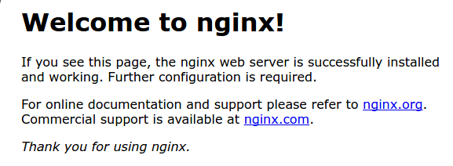
If you see the above page, you have successfully installed Nginx.

Step 2 – Installing MySQL to Manage Site Data
Now that you have a web server, you need to install MySQL (a database management system) to store and manage the data for your site.
Install MySQL by typing:
sudo apt install mysql-server
The MySQL database software is now installed, but its configuration is not yet complete.
To secure the installation, MySQL comes with a script that will ask whether we want to modify some insecure defaults. Initiate the script by typing:
sudo mysql_secure_installation
This script will ask if you want to configure the VALIDATE PASSWORD PLUGIN.
Warning: Enabling this feature is something of a judgment call. If enabled, passwords which don't match the specified criteria will be rejected by MySQL with an error. This will cause issues if you use a weak password in conjunction with software which automatically configures MySQL user credentials, such as the Ubuntu packages for phpMyAdmin. It is safe to leave validation disabled, but you should always use strong, unique passwords for database credentials.
Answer Y for yes, or anything else to continue without enabling.
VALIDATE PASSWORD PLUGIN can be used to test passwords
and improve security. It checks the strength of password
and allows the users to set only those passwords which are
secure enough. Would you like to setup VALIDATE PASSWORD plugin?

Press y|Y for Yes, any other key for No:
If you've enabled validation, the script will also ask you to select a level of password validation. Keep in mind that if you enter 2 – for the strongest level – you will receive errors when attempting to set any password which does not contain numbers, upper and lowercase letters, and special characters, or which is based on common dictionary words.
There are three levels of password validation policy:

LOW Length >= 8
MEDIUM Length >= 8, numeric, mixed case, and special characters
STRONG Length >= 8, numeric, mixed case, special characters and dictionary file

Please enter 0 = LOW, 1 = MEDIUM and 2 = STRONG: 1
Next, you'll be asked to submit and confirm a root password:
Please set the password for root here.

New password:

Re-enter new password:
For the rest of the questions, you should press Y and hit the ENTER key at each prompt. This will remove some anonymous users and the test database, disable remote root logins, and load these new rules so that MySQL immediately respects the changes we have made.
Note that in Ubuntu systems running MySQL 5.7 (and later versions), the root MySQL user is set to authenticate using the auth_socket plugin by default rather than with a password. This allows for some greater security and usability in many cases, but it can also complicate things when you need to allow an external program (e.g., phpMyAdmin) to access the user.
If using the auth_socket plugin to access MySQL fits with your workflow, you can proceed to Step 3. If, however, you prefer to use a password when connecting to MySQL as root, you will need to switch its authentication method from auth_socket to mysql_native_password. To do this, open up the MySQL prompt from your terminal:
sudo mysql
Next, check which authentication method each of your MySQL user accounts use with the following command:
SELECT user,authentication_string,plugin,host FROM mysql.user;
Output
+------------------+-------------------------------------------+-----------------------+-----------+
| user | authentication_string | plugin | host |
+------------------+-------------------------------------------+-----------------------+-----------+
| root | | auth_socket | localhost |
| mysql.session | *THISISNOTAVALIDPASSWORDTHATCANBEUSEDHERE | mysql_native_password | localhost |
| mysql.sys | *THISISNOTAVALIDPASSWORDTHATCANBEUSEDHERE | mysql_native_password | localhost |
| debian-sys-maint | *CC744277A401A7D25BE1CA89AFF17BF607F876FF | mysql_native_password | localhost |
+------------------+-------------------------------------------+-----------------------+-----------+
4 rows in set (0.00 sec)
In this example, you can see that the root user does in fact authenticate using the auth_socket plugin. To configure the root account to authenticate with a password, run the following ALTER USER command. Be sure to change password to a strong password of your choosing:
ALTER USER 'root'@'localhost' IDENTIFIED WITH mysql_native_password BY 'password';
Then, run FLUSH PRIVILEGES which tells the server to reload the grant tables and put your new changes into effect:
FLUSH PRIVILEGES;
Check the authentication methods employed by each of your users again to confirm that root no longer authenticates using the auth_socket plugin:
SELECT user,authentication_string,plugin,host FROM mysql.user;
Output
+------------------+-------------------------------------------+-----------------------+-----------+
| user | authentication_string | plugin | host |
+------------------+-------------------------------------------+-----------------------+-----------+
| root | *3636DACC8616D997782ADD0839F92C1571D6D78F | mysql_native_password | localhost |
| mysql.session | *THISISNOTAVALIDPASSWORDTHATCANBEUSEDHERE | mysql_native_password | localhost |
| mysql.sys | *THISISNOTAVALIDPASSWORDTHATCANBEUSEDHERE | mysql_native_password | localhost |
| debian-sys-maint | *CC744277A401A7D25BE1CA89AFF17BF607F876FF | mysql_native_password | localhost |
+------------------+-------------------------------------------+-----------------------+-----------+
4 rows in set (0.00 sec)
You can see in this example output that the root MySQL user now authenticates using a password. Once you confirm this on your own server, you can exit the MySQL shell:
exit
Note: After configuring your root MySQL user to authenticate with a password, you'll no longer be able to access MySQL with the sudo mysql command used previously. Instead, you must run the following:
mysql -u root -p
After entering the password you just set, you will see the MySQL prompt.
At this point, your database system is now set up and you can move on to installing PHP.

Step 3 – Installing PHP and Configuring Nginx to Use the PHP Processor
You now have Nginx installed to serve your pages and MySQL installed to store and manage your data. However, you still don't have anything that can generate dynamic content. This is where PHP comes into play.
Since Nginx does not contain native PHP processing like some other web servers, you will need to install php-fpm, which stands for "fastCGI process manager". We will tell Nginx to pass PHP requests to this software for processing.
Note: Depending on your cloud provider, you may need to add Ubuntu's universe repository, which includes free and open-source software maintained by the Ubuntu community, before installing the php-fpm package. You can do this by typing:
sudo add-apt-repository universe
Install the php-fpm module along with an additional helper package, php-mysql, which will allow PHP to communicate with your database backend. The installation will pull in the necessary PHP core files. Do this by typing:
sudo apt install php-fpm php-mysql
You now have all of the required LEMP stack components installed, but you still need to make a few configuration changes in order to tell Nginx to use the PHP processor for dynamic content.
This is done on the server block level (server blocks are similar to Apache's virtual hosts). To do this, open a new server block configuration file within the /etc/nginx/sites-available/ directory. In this example, the new server block configuration file is named example.com, although you can name yours whatever you’d like:
sudo nano /etc/nginx/sites-available/example.com
By editing a new server block configuration file, rather than editing the default one, you’ll be able to easily restore the default configuration if you ever need to.
Add the following content, which was taken and slightly modified from the default server block configuration file, to your new server block configuration file:
/etc/nginx/sites-available/example.com
server {
listen 80;
root /var/www/html;
index index.php index.html index.htm index.nginx-debian.html;
server_name example.com;

location / {
try_files $uri $uri/ =404;
}

location ~ \.php$ {
include snippets/fastcgi-php.conf;
fastcgi_pass unix:/var/run/php/php7.2-fpm.sock;
}

location ~ /\.ht {
deny all;
}
}
Here’s what each of these directives and location blocks do:
- listen — Defines what port Nginx will listen on. In this case, it will listen on port 80, the default port for HTTP.
- root — Defines the document root where the files served by the website are stored.
- index — Configures Nginx to prioritize serving files named index.php when an index file is requested, if they’re available.
- server_name — Defines which server block should be used for a given request to your server. Point this directive to your server's domain name or public IP address.
- location / — The first location block includes a try_files directive, which checks for the existence of files matching a URI request. If Nginx cannot find the appropriate file, it will return a 404 error.
- location ~ \.php$ — This location block handles the actual PHP processing by pointing Nginx to the fastcgi-php.conf configuration file and the php7.2-fpm.sock file, which declares what socket is associated with php-fpm.
- location ~ /\.ht — The last location block deals with .htaccess files, which Nginx does not process. By adding the deny all directive, if any .htaccess files happen to find their way into the document root they will not be served to visitors.
After adding this content, save and close the file. Enable your new server block by creating a symbolic link from your new server block configuration file (in the /etc/nginx/sites-available/ directory) to the /etc/nginx/sites-enabled/ directory:
sudo ln -s /etc/nginx/sites-available/example.com /etc/nginx/sites-enabled/
Then, unlink the default configuration file from the /sites-enabled/ directory:
sudo unlink /etc/nginx/sites-enabled/default
Note: If you ever need to restore the default configuration, you can do so by recreating the symbolic link, like this:
sudo ln -s /etc/nginx/sites-available/default /etc/nginx/sites-enabled/
Test your new configuration file for syntax errors by typing:
sudo nginx -t
If any errors are reported, go back and recheck your file before continuing.
When you are ready, reload Nginx to make the necessary changes:
sudo systemctl reload nginx
This concludes the installation and configuration of your LEMP stack. However, it’s prudent to confirm that all of the components can communicate with one another.

Step 4 – Creating a PHP File to Test Configuration
Your LEMP stack should now be completely set up. You can test it to validate that Nginx can correctly hand .php files off to the PHP processor.
To do this, use your text editor to create a test PHP file called info.php in your document root:
sudo nano /var/www/html/info.php
Enter the following lines into the new file. This is valid PHP code that will return information about your server:
/var/www/html/info.php
<?php
phpinfo();
When you are finished, save and close the file.
Now, you can visit this page in your web browser by visiting your server's domain name or public IP address followed by /info.php:
http://your_server_domain_or_IP/info.php
You should see a web page that has been generated by PHP with information about your server:
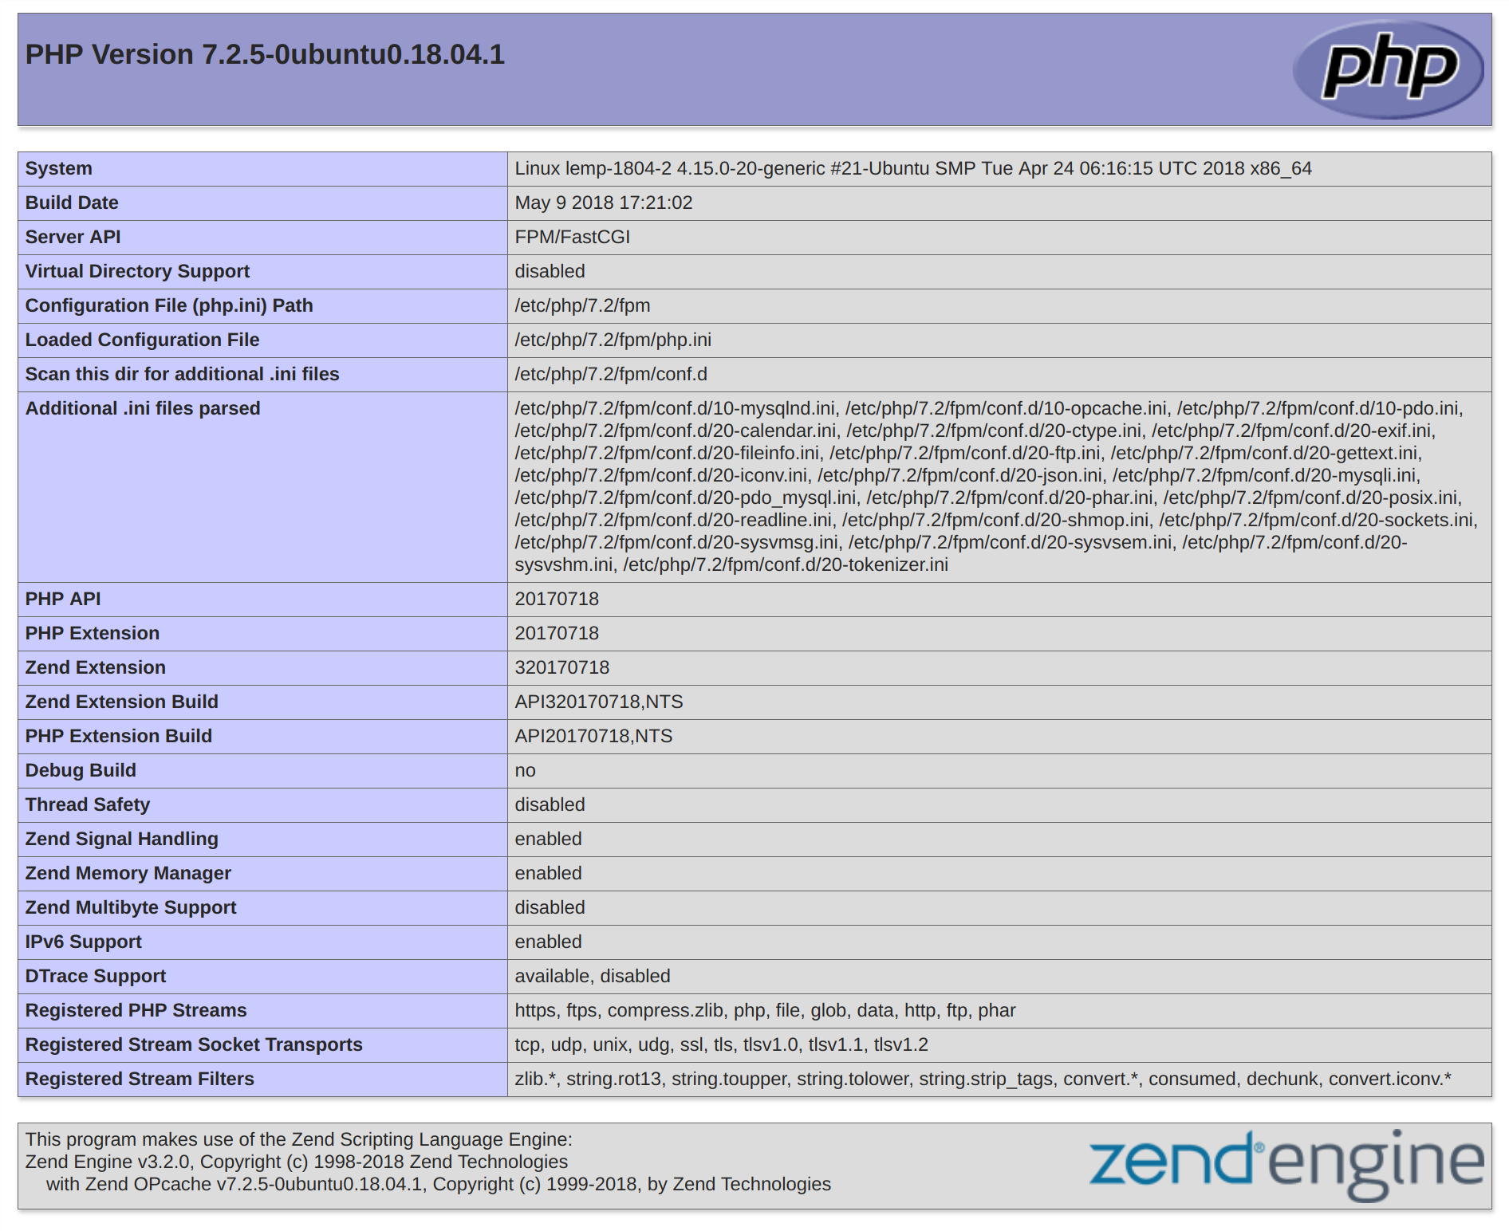
If you see a page that looks like this, you've set up PHP processing with Nginx successfully.
After verifying that Nginx renders the page correctly, it's best to remove the file you created as it can actually give unauthorized users some hints about your configuration that may help them try to break in. You can always regenerate this file if you need it later.
For now, remove the file by typing:
sudo rm /var/www/html/info.php
With that, you now have a fully-configured and functioning LEMP stack on your Ubuntu 18.04 server.

Conclusion
A LEMP stack is a powerful platform that will allow you to set up and serve nearly any website or application from your server.
There are a number of next steps you could take from here. For example, you should ensure that connections to your server are secured. To this end, you could secure your Nginx installation with Let’s Encrypt. By following this guide, you will acquire a free TLS/SSL certificate for your server, allowing it to serve content over HTTPS.
https://www.digitalocean.com/community/tutorials/how-to-install-linux-nginx-mysql-php-lemp-stack-ubuntu-18-04

How to Install Nginx with PHP and MySQL (LEMP Stack) on Ubuntu 18.04
Nginx (pronounced "engine x") is a free, open-source, high-performance HTTP server. Nginx is known for its stability, rich feature set, simple configuration, and low resource consumption. This tutorial shows how you can install Nginx on an Ubuntu 18.04 LTS server with PHP 7.2 support (through PHP-FPM) and MySQL support (LEMP = Linux + nginx (pronounced "engine x") + MySQL + PHP).

Prerequisites
- Ubuntu 18.04 LTS Server
- Root privileges

What we will do?
- Install Nginx
- Install MySQL
- Install PHP-FPM
- Configure Nginx and PHP-FPM
- Install PhpMyAdmin
- Configure PhpMyAdmin
- Testing

Step 1 - Install Nginx
Nginx or engine x is a high-performance HTTP and proxy server with low memory consumption. Most large-scale websites like Netflix, Pinterest, CloudFlare, GitHub are using Nginx.
In this step, we will install Nginx web server from the Ubuntu repository.

Run the command below.
sudo apt install nginx -y
After the installation is complete, start the Nginx service and enable it to launch every time at system boot.
systemctl start nginx
systemctl enable nginx
The Nginx installation is complete.

Configure the Firewall

It's recommended to turn on the firewall on the server.
Add the SSH and HTTP service port to the firewall configuration.
Run the UFW command below.
ufw allow ssh
ufw allow http
Now start the UFW firewall and enable it to launch everytime at system boot.
ufw enable
The Nginx web server is up and running under the UFW firewall.
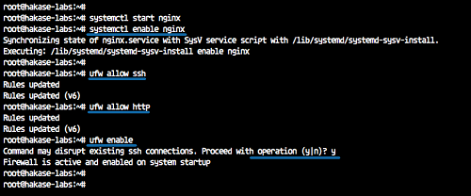

Step 2 - Install MySQL
MySQL is the most popular open source Relational Database Management System (RDBMS) created by Oracle Corporation. It's a central component of the LEMP Stack, and we will install the latest MySQL version from the Ubuntu repository.
Install MySQL using the apt command below.
sudo apt install mysql-server mysql-client -y
After the MySQL installation is complete, start the MySQL service and enable it to launch everytime at system boot.
systemctl start mysql
systemctl enable mysql
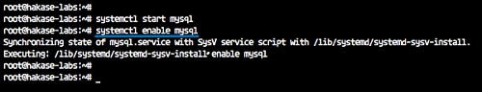
And we've installed MySQL 5.7 on Ubuntu 18.04 server.

Step 3 - Install PHP-FPM
PHP-FPM or FastCGI Process Manager is an alternative for the older PHP FastCGI which provides additional features and speed improvements. It suits well for small to large sites based on the PHP programming language.
In this step, we will install PHP7.2-FPM with some additional extensions required by phpmyadmin.
Install PHP-FPM using the command below.
sudo apt install php7.2 php7.2-fpm php7.2-cli php7.2-curl php7.2-mysql php7.2-curl php7.2-gd php7.2-mbstring php-pear -y
Now start the PHP-FPM service and enable it to launch every time at system boot after all installation is complete.
systemctl start php7.2-fpm
systemctl enable php7.2-fpm
PHP7.2-FPM is up and running on Ubuntu 18.04 under the sock file, check it using the netstat command.
netstat -pl | grep php
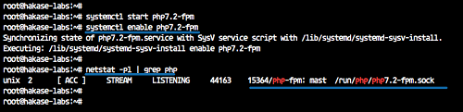

Step 4 - Configure Nginx and PHP-FPM
In this step, we will configure the Nginx web server and PHP-FPM.

Configure Nginx
Go to the '/etc/nginx' configuration directory, and edit the 'nginx.conf' file using vim or nano.
cd /etc/nginx/
vim nginx.conf
Uncomment the following lines.
keepalive_timeout 2;
server_tokens off;
Save the configuration file and exit the editor.
Now edit the default Nginx virtual host file.
vim sites-available/default
Uncomment the PHP line shown below and change the sock file line.
location ~ \.php$ {
include snippets/fastcgi-php.conf;
#
# # With php-fpm (or other unix sockets):
fastcgi_pass unix:/var/run/php/php7.2-fpm.sock;
# # With php-cgi (or other tcp sockets):
# fastcgi_pass 127.2.0.1:9000;
}
Save and exit.
Test Nginx configuration and make sure there is no error, then restart the service.
nginx -t
systemctl reload nginx
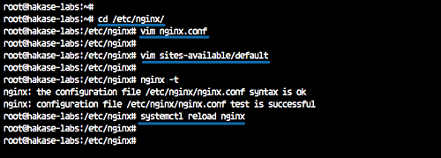

Configure PHP-FPM
Go to the '/etc/php/7.2' directory and edit the 'php.ini' file.
cd /etc/php/7.2/
vim fpm/php.ini
Uncomment the 'cgi.fix_patinfo' line and change the value to '0'.
cgi.fix_pathinfo=0
Save and exit.
Reload the PHP-FPM service.
systemctl reload php7.2-fpm
And we've completed configuration of Nginx web server and PHP-FPM.

Step 5 - Install PhpMyAdmin
PhpMyAdmin is a PHP based application to manage MySQL or MariaDB databases from a web browser.
In this step, we will install and configure phpmyadmin under the LEMP (Linux, Nginx, MySQL, and PHP-FPM) stack.
Install PHPMyAdmin using the apt command below.
sudo apt install phpmyadmin -y
During the installation, it will ask you about the web server configuration for phpmyadmin.
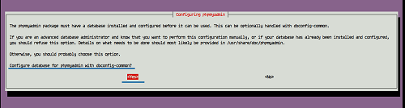
Choose none option and move the cursor to 'OK'.
For the phpmyadmin database configuration, choose 'Yes'.
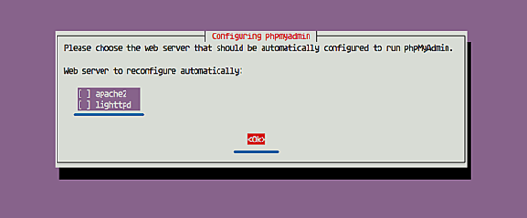
And type new 'STRONG' phpmyadmin admin such as 'Hakaselabs001@#'.

Repeat the 'Hakaselabs001@#' password.
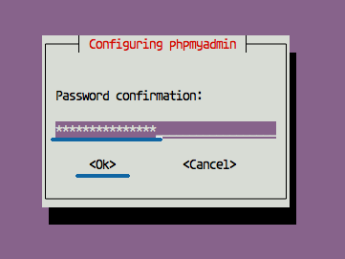
And the phpmyadmin installation is complete.

Step 6 - Configure PhpMyAdmin
After the phpmyadmin installation, we need to configure phpmyadmin to run under the Nginx web server and configure the MySQL user phpmyadmin access.

Configure PhpMyAdmin with Nginx
In order to run phpmyadmin under the Nginx web server, we need to add the configuration to the virtual host configuration file.
Go to the '/etc/nginx' configuration directory, and edit the default virtual host file.
cd /etc/nginx/
vim sites-available/default
Paste the following Nginx configuration for phpmyadmin inside the 'server {...}' bracket.
location /phpmyadmin {
root /usr/share/;
index index.php;
try_files $uri $uri/ =404;

location ~ ^/phpmyadmin/(doc|sql|setup)/ {
deny all;
}

location ~ /phpmyadmin/(.+\.php)$ {
fastcgi_pass unix:/var/run/php/php7.2-fpm.sock;
fastcgi_param SCRIPT_FILENAME $document_root$fastcgi_script_name;
include fastcgi_params;
include snippets/fastcgi-php.conf;
}
}
Save and exit.
Test the nginx configuration and restart the nginx service.
nginx -t
systemctl reload nginx
And we've added the Nginx configuration for phpmyadmin.

Configure MySQL User for PhpMyAdmin
In this tutorial, we will be using non-root MySQL user for phpmyadmin. We will create a new user and grant all privileges of database inside the server to the user.
Login to the MySQL shell.
mysql -u root -p
Now create a new user using the MySQL queries below.
create user hakase@'localhost' identified by 'Hakaselabs001@#';
grant all privileges on *.* to hakase@'localhost' identified by 'Hakaselabs001@#';
flush privileges;
exit;
And we've created a new user for phpmyadmin access.
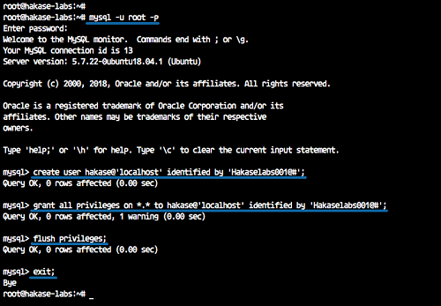

Step 7 - Testing

Test PHP Files
Go to the web-root directory '/var/www/html' and create a new phpinfo file.
cd /var/www/html/
vim info.php
Paste the phpinfo script below.
<?php
phpinfo();
?>
Save and exit.
Now open the web browser and type the server IP address as shown below. Replace the IP with your server ip.
http://192.168.33.10/info.php
And below is all information about PHP server configuration.
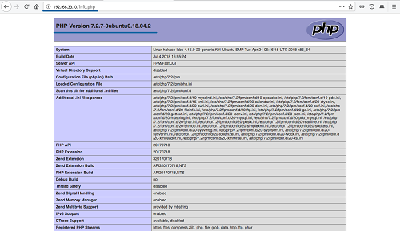

Test Login PhpMyAdmin
On the web browser, type the following phpmyadmin URL (replace the IP with your server IP).
http://192.168.33.10/phpmyadmin/
On the phpmyadmin login page, type the user 'hakase' with password 'Hakaselabs001@#' and click the 'Go' button.
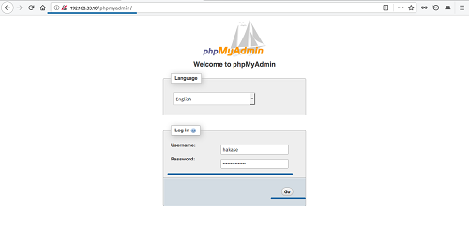
Now we will see the phpmyadmin dashboard as below.
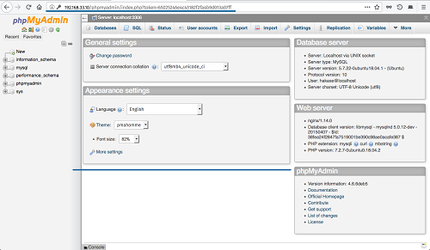
The LEMP Stack and PhpMyAdmin are successfully installed on Ubuntu 18.04 LTS.
About Muhammad Arul
Muhammad Arul is a freelance system administrator and technical writer. He is working with Linux Environments for more than 5 years, an Open Source enthusiast and highly motivated on Linux installation and troubleshooting. Mostly working with RedHat/CentOS Linux and Ubuntu/Debian, Nginx and Apache web server, Proxmox, Zimbra Administration, and Website Optimization. Currently learning about OpenStack and Container Technology.
https://www.howtoforge.com/tutorial/how-to-install-nginx-with-php-and-mysql-lemp-on-ubuntu-1804/

Installing Nginx, MySQL, PHP (LEMP) Stack on Ubuntu 18.04
Last updated on
Ubuntu Server 18.04 LTS (Bionic Beaver) is finally here and is being rolled out across VPS hosts such as DigitalOcean and AWS. In this guide we will install a LEMP Stack (Nginx, MySQL, PHP) and configure a web server.

Prerequisites
You should use a non-root user account with sudo privileges. Please see the Initial server setup for Ubuntu 18.04 guide for more details.

1. Install Nginx
Let’s begin by updating the package lists and installing Nginx on Ubuntu 18.04. Below we have two commands separated by &&. The first command will update the package lists to ensure you get the latest version and dependencies for Nginx. The second command will then download and install Nginx.
sudo apt update && sudo apt install nginx
Once installed, check to see if the Nginx service is running.
sudo service nginx status
If Nginx is running correctly, you should see a green Active state below.
● nginx.service - A high performance web server and a reverse proxy server
Loaded: loaded (/lib/systemd/system/nginx.service; enabled; vendor preset: enabled)
Active: active (running) since Wed 2018-05-09 20:42:29 UTC; 2min 39s ago
Docs: man:nginx(8)
Process: 27688 ExecStart=/usr/sbin/nginx -g daemon on; master_process on; (code=exited, status=0/SUCCESS)
Process: 27681 ExecStartPre=/usr/sbin/nginx -t -q -g daemon on; master_process on; (code=exited, status=0/SUCCESS)
Main PID: 27693 (nginx)
Tasks: 2 (limit: 1153)
CGroup: /system.slice/nginx.service
├─27693 nginx: master process /usr/sbin/nginx -g daemon on; master_process on;
└─27695 nginx: worker process
You may need to press q to exit the service status.

2. Configure Firewall
If you haven’t already done so, it is recommended that you enable the ufw firewall and add a rule for Nginx. Before enabling ufw firewall, make sure you add a rule for SSH, otherwise you may get locked out of your server if you’re connected remotely.
sudo ufw allow OpenSSH
If you get an error “ERROR: could find a profile matching openSSH”, this probably means you are not configuring the server remotely and can ignore it.
Now add a rule for Nginx.
sudo ufw allow 'Nginx HTTP'
Rule added
Rule added (v6)
Enable ufw firewall.
sudo ufw enable
Press y when asked to proceed.
Now check the firewall status.
sudo ufw status
Status: active

To Action From
-- ------ ----
OpenSSH ALLOW Anywhere
Nginx HTTP ALLOW Anywhere
OpenSSH (v6) ALLOW Anywhere (v6)
Nginx HTTP (v6) ALLOW Anywhere (v6)
That’s it! Your Nginx web server on Ubuntu 18.04 should now be ready.

3. Test Nginx
Go to your web browser and visit your domain or IP. If you don’t have a domain name yet and don’t know your IP, you can find out with:
sudo ifconfig | grep -Eo 'inet (addr:)?([0-9]*\.){3}[0-9]*' | grep -Eo '([0-9]*\.){3}[0-9]*' | grep -v '127.0.0.1'
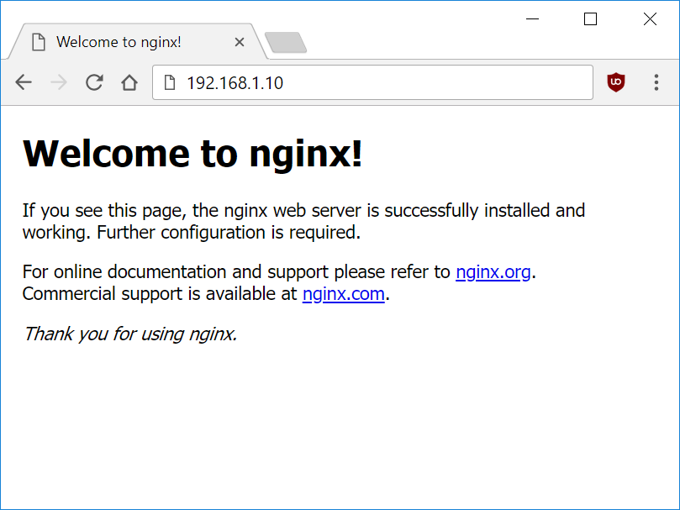
You can find this Nginx default welcome page in the document root directory /var/www/html. To edit this file in nano text editor:
sudo nano /var/www/html/index.nginx-debian.html
To save and close nano, press CTRL + X and then press y and ENTER to save changes.
Your Nginx web server is ready to go! You can now add your own html files and images the the /var/www/html directory as you please.
However, you should acquaint yourself with and set up at least one Server Block for Nginx as most of our Ubuntu 18.04 guides are written with Server Blocks in mind. Please see article Installing Nginx on Ubuntu 18.04 with Multiple Domains. Server Blocks allow you to host multiple web sites/domains on one server. Even if you only ever intend on hosting one website or one domain, it’s still a good idea to configure at least one Server Block.
If you don’t want to set up Server Blocks, continue to the next step to set up MySQL.

4. Install MySQL
Let’s begin by updating the package lists and installing MySQL on Ubuntu 18.04. Below we have two commands separated by &&. The first command will update the package lists to ensure you get the latest version and dependencies for MySQL. The second command will then download and install MySQL.
sudo apt update && sudo apt install mysql-server
Press y and ENTER when prompted to install the MySQL package.
Once the package installer has finished, we can check to see if the MySQL service is running.
sudo service mysql status
If running, you will see a green Active status like below.
● mysql.service - MySQL Community Server
Loaded: loaded (/lib/systemd/system/mysql.service; enabled; vendor preset: enabled)
Active: active (running) since since Wed 2018-05-09 21:10:24 UTC; 16s ago
Main PID: 30545 (mysqld)
Tasks: 27 (limit: 1153)
CGroup: /system.slice/mysql.service
└─30545 /usr/sbin/mysqld --daemonize --pid-file=/run/mysqld/mysqld.pid
You may need to press q to exit the service status.

5. Configure MySQL Security
You should now run mysql_secure_installation to configure security for your MySQL server.
sudo mysql_secure_installation
If you created a root password in Step 1, you may be prompted to enter it here. Otherwise you will be asked to create one. (Generate a password here)
You will be asked if you want to set up the Validate Password Plugin. It’s not really necessary unless you want to enforce strict password policies for some reason.
Securing the MySQL server deployment.

Connecting to MySQL using a blank password.

VALIDATE PASSWORD PLUGIN can be used to test passwords
and improve security. It checks the strength of password
and allows the users to set only those passwords which are
secure enough. Would you like to setup VALIDATE PASSWORD plugin?

Press y|Y for Yes, any other key for No:
Press n and ENTER here if you don’t want to set up the validate password plugin.
Please set the password for root here.

New password:

Re-enter new password:
If you didn’t create a root password in Step 1, you must now create one here.
Generate a strong password and enter it. Note that when you enter passwords in Linux, nothing will show as you are typing (no stars or dots).
By default, a MySQL installation has an anonymous user,
allowing anyone to log into MySQL without having to have
a user account created for them. This is intended only for
testing, and to make the installation go a bit smoother.
You should remove them before moving into a production
environment.

Remove anonymous users? (Press y|Y for Yes, any other key for No) :
Press y and ENTER to remove anonymous users.
Normally, root should only be allowed to connect from
'localhost'. This ensures that someone cannot guess at
the root password from the network.

Disallow root login remotely? (Press y|Y for Yes, any other key for No) :
Press y and ENTER to disallow root login remotely. This will prevent bots and hackers from trying to guess the root password.
By default, MySQL comes with a database named 'test' that
anyone can access. This is also intended only for testing,
and should be removed before moving into a production
environment.

Remove test database and access to it? (Press y|Y for Yes, any other key for No) :
Press y and ENTER to remove the test database.
Reloading the privilege tables will ensure that all changes
made so far will take effect immediately.

Reload privilege tables now? (Press y|Y for Yes, any other key for No) :
Press y and ENTER to reload the privilege tables.
All done!
As a test, you can log into the MySQL server and run the version command.
sudo mysqladmin -p -u root version
Enter the MySQL root password you created earlier and you should see the following:
mysqladmin Ver 8.42 Distrib 5.7.22, for Linux on x86_64
Copyright (c) 2000, 2018, Oracle and/or its affiliates. All rights reserved.

Oracle is a registered trademark of Oracle Corporation and/or its
affiliates. Other names may be trademarks of their respective
owners.

Server version 5.7.22-0ubuntu18.04.1
Protocol version 10
Connection Localhost via UNIX socket
UNIX socket /var/run/mysqld/mysqld.sock
Uptime: 4 min 28 sec

Threads: 1 Questions: 15 Slow queries: 0 Opens: 113 Flush tables: 1 Open tables: 106 Queries per second avg: 0.055
You have now successfully installed and configured MySQL for Ubuntu 18.04! Continue to the next step to install PHP.

6. Install PHP
Unlike Apache, Nginx does not contain native PHP processing. For that we have to install PHP-FPM (FastCGI Process Manager). FPM is an alternative PHP FastCGI implementation with some additional features useful for heavy-loaded sites.
Let’s begin by updating the package lists and installing PHP-FPM on Ubuntu 18.04. We will also install php-mysql to allow PHP to communicate with the MySQL database. Below we have two commands separated by &&. The first command will update the package lists to ensure you get the latest version and dependencies for PHP-FPM and php-mysql. The second command will then download and install PHP-FPM and php-mysql. Press y and ENTER when asked to continue.
sudo apt update && sudo apt install php-fpm php-mysql
Once installed, check the PHP version.
php --version
If PHP was installed correctly, you should see something similar to below.
PHP 7.2.3-1ubuntu1 (cli) (built: Mar 14 2018 22:03:58) ( NTS )
Copyright (c) 1997-2018 The PHP Group
Zend Engine v3.2.0, Copyright (c) 1998-2018 Zend Technologies
with Zend OPcache v7.2.3-1ubuntu1, Copyright (c) 1999-2018, by Zend Technologies
Above we are using PHP version 7.2, though this may be a later version for you.
Depending on what version of Nginx and PHP you install, you may need to manually configure the location of the PHP socket that Nginx will connect to.
List the contents for the directory /var/run/php/
ls /var/run/php/
You should see a few entries here.
php7.2-fpm.pid php7.2-fpm.sock
Above we can see the socket is called php7.2-fpm.sock. Remember this as you may need it for the next step.

7. Configure Nginx for PHP
We now need to make some changes to our Nginx server block.
The location of the server block may vary depending on your setup. By default, it is located in /etc/nginx/sites-available/default.
However, if you have previously set up custom server blocks for multiple domains in one of our previous guides, you will need to add the PHP directives to each server block separately. A typical custom server block file location would be /etc/nginx/sites-available/mytest1.com.
For the moment, we will assume you are using the default. Edit the file in nano.
sudo nano /etc/nginx/sites-available/default
Press CTRL + W and search for index.html.
Now add index.php before index.html
/etc/nginx/sites-available/default
index index.php index.html index.htm index.nginx-debian.html;
Press CTRL + W and search for the line server_name.
Enter your server’s IP here or domain name if you have one.
/etc/nginx/sites-available/default
server_name YOUR_DOMAIN_OR_IP_HERE;
Press CTRL + W and search for the line location ~ \.php.
You will need to uncomment some lines here by removing the # signs before the lines marked in red below.
Also ensure value for fastcgi_pass socket path is correct. For example, if you installed PHP version 7.2, the socket should be: /var/run/php/php7.2-fpm.sock
If you are unsure which socket to use here, exit out of nano and run ls /var/run/php/
/etc/nginx/sites-available/default
...
location ~ \.php$ {
include snippets/fastcgi-php.conf;
#
# # With php-fpm (or other unix sockets):
fastcgi_pass unix:/var/run/php/php7.2-fpm.sock;
# # With php-cgi (or other tcp sockets):
# fastcgi_pass 127.0.0.1:9000;
}
...
Once you’ve made the necessary changes, save and close (Press CTRL + X, then press y and ENTER to confirm save)
Now check the config file to make sure there are no syntax errors. Any errors could crash the web server on restart.
sudo nginx -t
nginx: the configuration file /etc/nginx/nginx.conf syntax is ok
nginx: configuration file /etc/nginx/nginx.conf test is successful
If no errors, you can reload the Nginx config.
sudo service nginx reload

8. Test PHP
To see if PHP is working correctly on Ubuntu 18.04, let’s a create a new PHP file called info.php in the document root directory. By default, this is located in /var/www/html/, or if you set up multiple domains in a previous guide, it may be located in somewhere like /var/www/mytest1.com/public_html
Once you have the correct document root directory, use the nano text editor to create a new file info.php
sudo nano /var/www/html/info.php
Type or paste the following code into the new file. (if you’re using PuTTY for Windows, right-click to paste)
/var/www/html/info.php
<?php
phpinfo();
Save and close (Press CTRL + X, then press y and ENTER to confirm save)
You can now view this page in your web browser by visiting your server’s domain name or public IP address followed by /info.php: http://your_domain_or_IP/info.php
phpinfo() outputs a large amount of information about the current state of PHP. This includes information about PHP compilation options and extensions, the PHP version and server information.
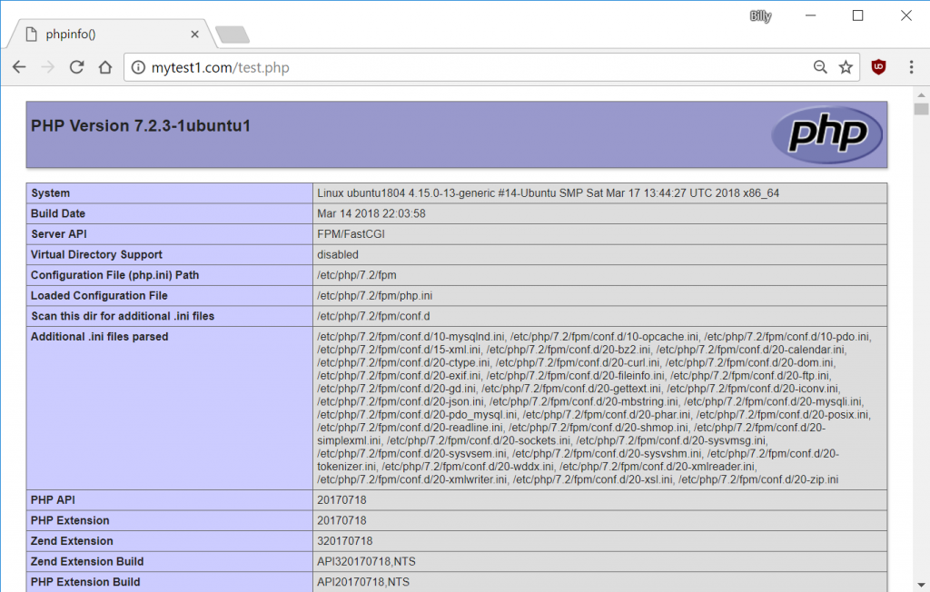
You have now successfully installed PHP-FPM for Nginx on Ubuntu 18.04 LTS (Bionic Beaver).
Make sure to delete info.php as it contains information about the web server that could be useful to attackers.
sudo rm /var/www/html/info.php
https://devanswers.co/installing-nginx-mysql-php-lemp-stack-ubuntu-18-04/

Install a LEMP Stack on Ubuntu 18.04
Updated by Edward Written by Linode
Use promo code DOCS10 for $10 credit on a new account.
Contribute on GitHub
Report an Issue | View File | Edit File

What is a LEMP Stack?Permalink
The LAMP stack (Linux, Apache, MariaDB, and PHP) is a popular server configuration for developing and hosting web applications. The four components of the stack are not tightly coupled, making it possible to substitute your preferred technologies. The LEMP stack is a common variant in which the Apache web server is replaced by NGINX.

Before You BeginPermalink
- You will need root access to the system, or a user account with sudo privilege.
- Set your system’s hostname.
- Update your system:
sudo apt update && sudo apt upgrade

InstallationPermalink

NGINXPermalink
Install NGINX from the package repository:
sudo apt install nginx

MariaDBPermalink
- Install the MariaDB server and MySQL/MariaDB-PHP support:
sudo apt install mariadb-server php-mysql
MariaDB is a popular fork of MySQL, and its development is considered to be more open and transparent than MySQL’s. MariaDB is administered with the same commands as MySQL.
- Log in to MariaDB’s SQL shell:
sudo mysql -u root
The database will not prompt you for a password, as it is initially configured to use the unix_socket authorization plugin. This authorization scheme allows you to log in to the database’s root user as long as you are connecting from the Linux root user on localhost:
MariaDB [(none)]> SELECT user,host,authentication_string,plugin FROM mysql.user;
+------+-----------+-----------------------+-------------+
| user | host | authentication_string | plugin |
+------+-----------+-----------------------+-------------+
| root | localhost | | unix_socket |
+------+-----------+-----------------------+-------------+
1 row in set (0.00 sec)
You can keep using the unix_socket plugin for the root user; this is considered a secure option for production systems, and it is needed for certain Ubuntu maintenance scripts to run normally. Further reading on this subject is available in /usr/share/doc/mariadb-server-10.1/README.Debian.gz on your filesystem.
- Create a test database and user with access permission. Replace testdb and testuser with appropriate names for your setup. Replace password with a strong password.
CREATE DATABASE testdb;
CREATE USER 'testuser' IDENTIFIED BY 'password';
GRANT ALL PRIVILEGES ON testdb.* TO 'testuser';
- Exit the SQL shell:
quit
- Use the mysql_secure_installation tool to configure additional security options. This tool will ask if you want to set a new password for the MySQL root user, but you can skip that step:
sudo mysql_secure_installation
Answer Y at the following prompts:
  - Remove anonymous users?
  - Disallow root login remotely?
  - Remove test database and access to it?
  - Reload privilege tables now?

PHPPermalink
- Install the PHP FastCGI Processing Manager, which includes the core PHP dependencies:
sudo apt install php-fpm
- Tell PHP to only accept URIs for files that actually exist on the server. This mitigates a security vulnerability where the PHP interpreter can be tricked into allowing arbitrary code execution if the requested .php file is not present in the filesystem. See this tutorial for more information about this vulnerability.
sudo sed -i 's/;cgi.fix_pathinfo=1/cgi.fix_pathinfo=0/g' /etc/php/7.2/fpm/php.ini

Set an NGINX Site Configuration FilePermalink
- Create a root directory where the site’s content will live. Replace example.com with your site’s domain.
sudo mkdir -p /var/www/html/example.com/public_html
- Delete the default site configuration provided with the package as an example:
sudo rm -f /etc/nginx/sites-enabled/default
- Website configuration files should be kept in /etc/nginx/sites-available/. Create a configuration file inside this directory with the example content. Replace example.com with your domain in both the file name and in the file’s contents:
/etc/nginx/sites-available/example.com.conf
1  2  3  4  5  6  7  8  9  10  11  12  13  14  15  16  17  18 | server {  listen 80 default_server;  listen [::]:80 default_server;  server_name example.com www.example.com;  root /var/www/html/example.com/public_html;  index index.html;  location / {  try_files $uri $uri/ =404;  }  location ~* \.php$ {  fastcgi_pass unix:/run/php/php7.2-fpm.sock;  include fastcgi_params;  fastcgi_param SCRIPT_FILENAME $document_root$fastcgi_script_name;  fastcgi_param SCRIPT_NAME $fastcgi_script_name;  }  }
Here’s a breakdown of the server block above:
  - NGINX is listening on port 80 for incoming connections to example.com or www.example.com.
  - The site is served out of /var/www/html/example.com/public_html and its index page (index.html) is a simple .html file. If your index page will use PHP like WordPress does, substitute index.html for index.php.
  - try_files tells NGINX to verify that a requested file or directory actually exists in the site’s root filesystem before further processing the request. If it does not, a 404 is returned.
  - location ~* \.php$ means that NGINX will apply this configuration to all .php files (file names are not case sensitive) in your site’s root directory, including any subdirectories containing PHP files.
  - The * in the ~* \.php$ location directive indicates that PHP file names are not case sensitive. This can be removed if you prefer to enforce letter case.
  - fastcgi_pass specifies the UNIX socket where PHP listens for incoming connections from other local processes
  - include fastcgi_params tells NGINX to process a list of fastcgi_param variables at /etc/nginx/fastcgi_params.
  - The fastcgi_param directives contain the location (relative to the site’s root directory) and file naming convention of PHP scripts to be served when called by NGINX.
- Create a link to your website configuration file from within the sites-enabled directory. Change the name of the file to the name you used for your domain:
sudo ln -s /etc/nginx/sites-available/example.com.conf /etc/nginx/sites-enabled/

Test the LEMP StackPermalink
- To ensure that your web server can be reached with your domain name, configure the DNS records for your domain to point to your Linode’s IP address.
- Restart PHP and reload the NGINX configuration:
sudo systemctl restart php7.2-fpm
sudo nginx -s reload
- Test the NGINX configuration:
sudo nginx -t
- Create a test page to verify NGINX can render PHP and connect to the MariaDB database. Replace the "testuser" and "password" fields with the MariaDB credentials you created above.
/var/www/html/example.com/public_html/test.php
1  2  3  4  5  6  7  8  9  10  11  12  13  14  15  16  17  18  19  20  21  22  23  24 | <html>  <head>  <h2>LEMP Stack Test</h2>  </head>  <body>  <?php echo '<p>Hello,</p>';  // Define PHP variables for the MySQL connection.  $servername = "localhost";  $username = "testuser";  $password = "password";  // Create a MySQL connection.  $conn = mysqli_connect($servername, $username, $password);  // Report if the connection fails or is successful.  if (!$conn) {  exit('<p>Your connection has failed.<p>' . mysqli_connect_error());  }  echo '<p>You have connected successfully.</p>';  ?>  </body>  </html>
- Go to http://example.com/test.php in a web browser. It should report that You have connected successfully. If you see an error message or if the page does not load at all, re-check your configuration. If your DNS changes haven’t propagated yet, you can test your page with curl instead:
$ curl -H "Host: example.com" http://<your-ip-address>/test.php
<html>
<head>
<h2>LEMP Stack Test</h2>
</head>
<body>
<p>Hello,</p><p>You have connected successfully.</p></body>
</html>
- Remove the test file once the stack is working correctly:
sudo rm /var/www/html/example.com/public_html/test.php
https://www.linode.com/docs/web-servers/lemp/how-to-install-a-lemp-server-on-ubuntu-18-04/

